Name of Student: Akshit Kumar | PRN:25070122270
Semester: III | Year : AY 2026-27
Subject: Programming with Java
ASSIGNMENT No : 11
TITLE : Interface Implementation
Problem Statement
Write a Java program to demonstrate the implementation of interfaces.
Learning Objectives
To implement interfaces for achieving abstraction and multiple inheritance of type.

Programme
- Create an interface Printable and implement it in Student and Employee classes.
interface Printable {
void printDetails();
}

class Student implements Printable {
public void printDetails() {
System.out.println("Student Name: Rahul");
System.out.println("Course: BCA");

}
}

class Employee implements Printable {

public void printDetails() {
System.out.println("Employee Name: Amit");
System.out.println("Department: IT");

}
}
public class PrintableDemo {

public static void main(String[] args) {
Printable student = new Student();
Printable employee = new Employee();
System.out.println("--- Student Details ---");
student.printDetails();
System.out.println();
System.out.println("--- Employee Details ---");
employee.printDetails();
}
}

- Create an interface Switchable with a method turnOn(). Implement the interface in Light and Fan classes to display the device status.
interface Switchable {
void turnOn();
void turnOff();
}

class Light implements Switchable {

public void turnOn() {
System.out.println("Light is ON");
}
public void turnOff() {
System.out.println("Light is OFF");
}
}

class Fan implements Switchable {
public void turnOn() {
System.out.println("Fan is ON");
}
public void turnOff() {
System.out.println("Fan is OFF");
}
}

public class SwitchableDemo {
public static void main(String[] args) {
Switchable light = new Light();
Switchable fan = new Fan();

System.out.println(" Light Status ");
light.turnOn();
light.turnOff();

System.out.println();
System.out.println(" Fan Status ");
fan.turnOn();
fan.turnOff();
}
}

Output
1)
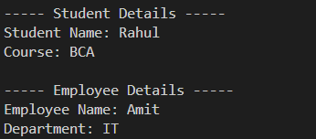
2)
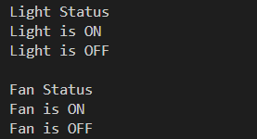

Conclusion
Thus, the program successfully demonstrates how an interface can define common behavior for different classes.

